CLOUD COMPUTING
LAB 14



Submitted To:
Engr. Shoaib

Submitted By:
Komal Kashif
BSE V-A
2023-BSE-031

Task 1 – Generate ssh key and Initial Terraform apply
task1_ssh_keygen_before.png
task1_ssh_keygen.png
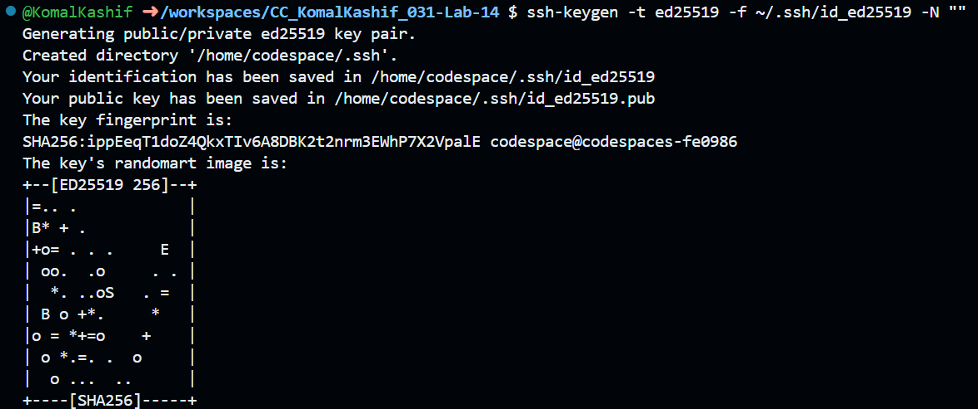
task1_ssh_keygen_after.png
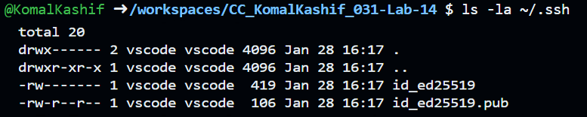
task1_terraform_tfvars_created.png
task1_terraform_tfvars.png
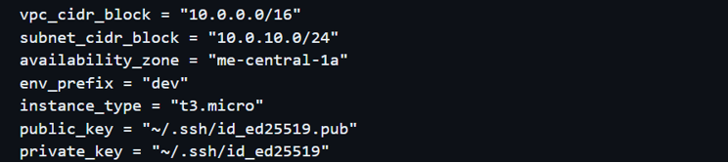

task1_terraform_init.png
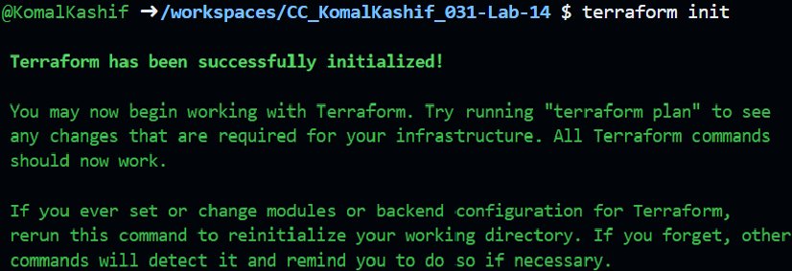
task1_terraform_apply_2_instances.png
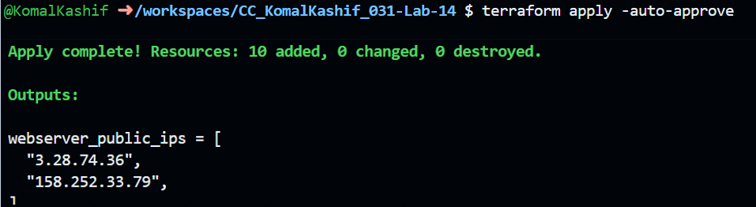
task1_terraform_output_ips.png
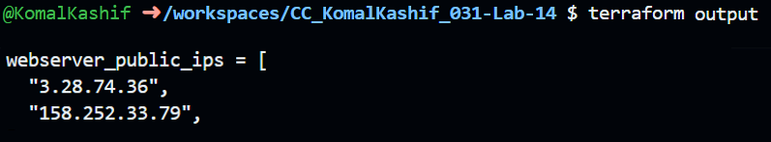
Task 2 – Static Ansible inventory with two EC2 instances
task2_ansible_install.png
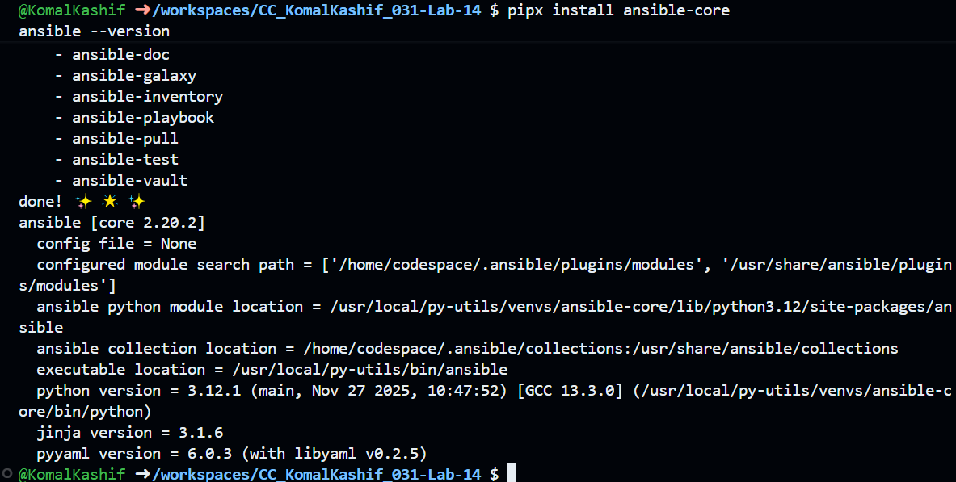

task2_terraform_output_ips.png
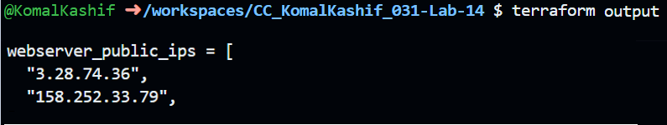
task2_hosts_created.png
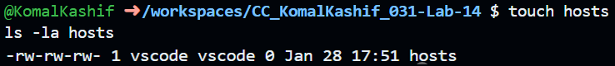
task2_hosts_initial.png
task2_ansible_ping_initial.png
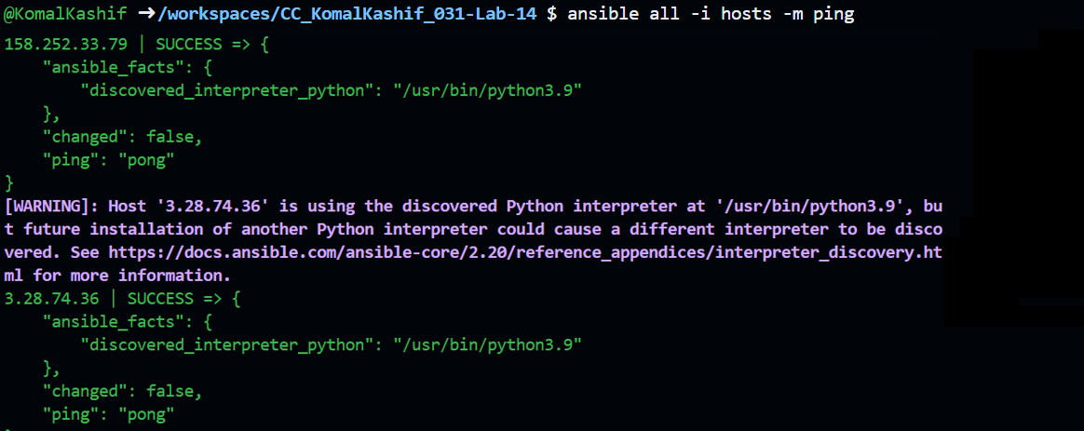
task2_hosts_with_common_args.png
task2_ansible_ping_success.png
Task 3 - Scale to three instances & group-based inventory
task3_main_tf_count_3.png
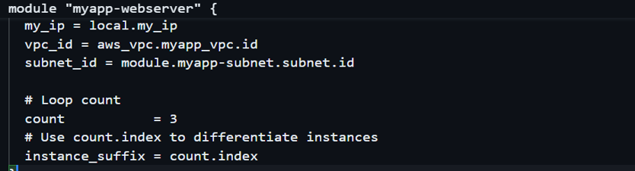
task3_terraform_apply_3_instances.png
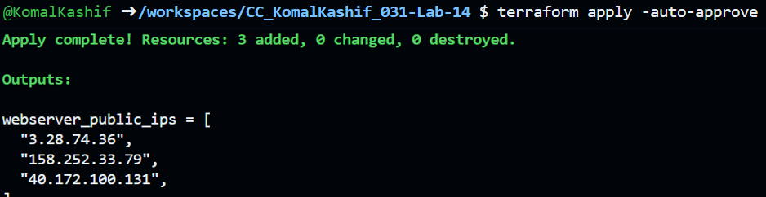
task3_terraform_output_3_ips.png
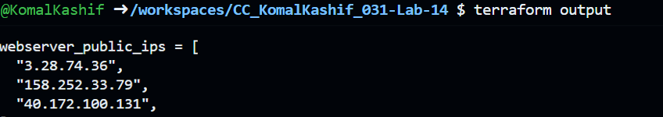
task3_hosts_grouped.png
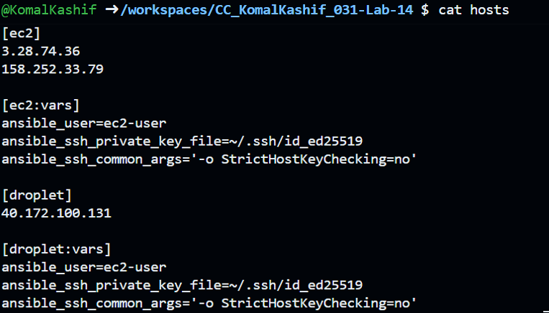

task3_ansible_ec2_ping.png
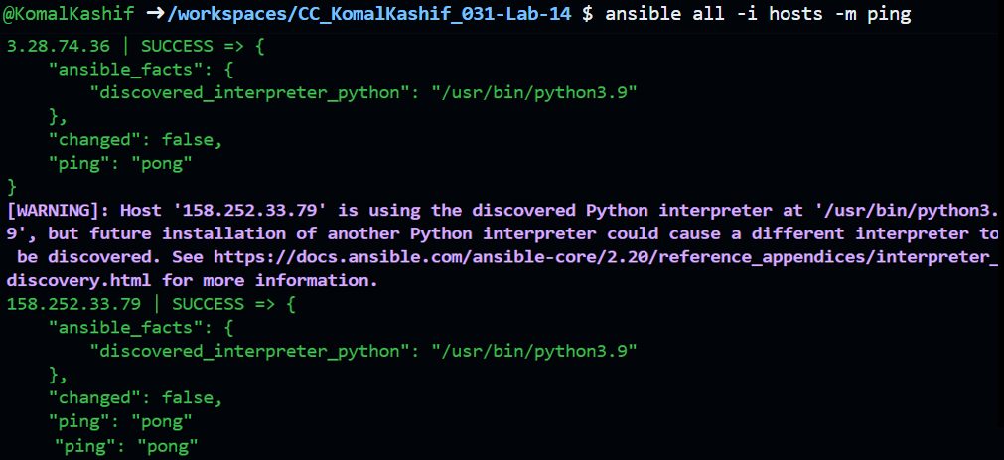
task3_ansible_single_ip_ping.png
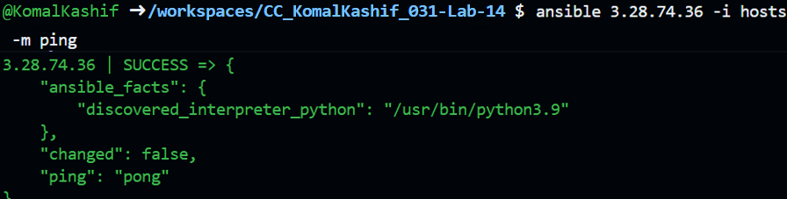
task3_ansible_droplet_ping.png
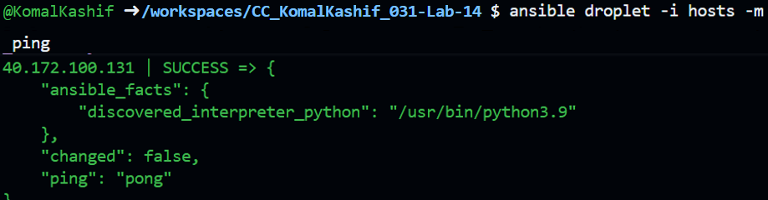
Task 4 – Global ansible.cfg & first nginx playbook
task4_global_ansible_cfg.png
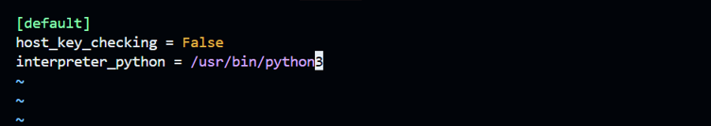

task4_hosts_without_common_args.png
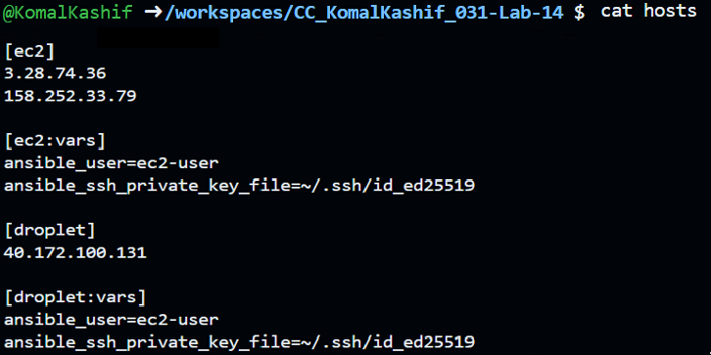
task4_ansible_ping_after_cfg.png
task4_my_playbook_created.png
task4_my_playbook_ec2.png
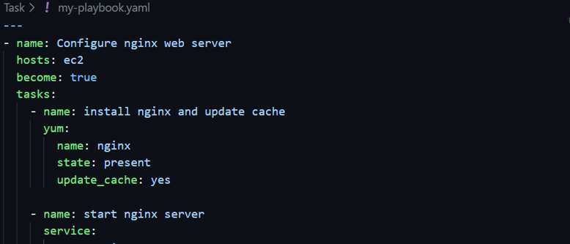

task4_ansible_play_ec2.png
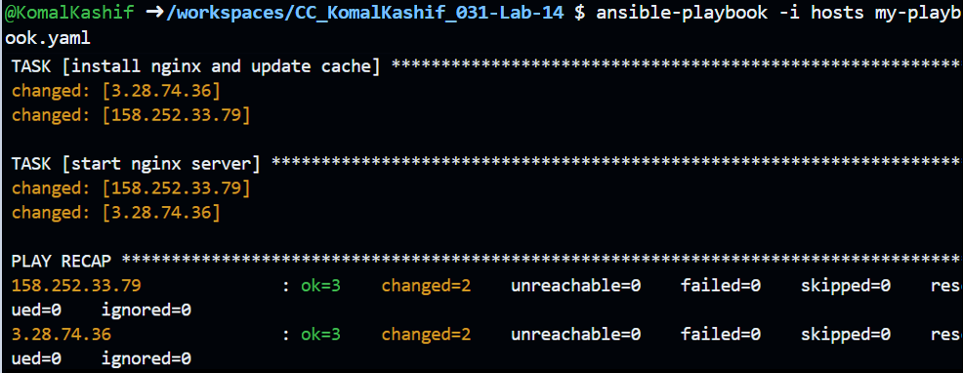
task4_nginx_browser_ec2.png
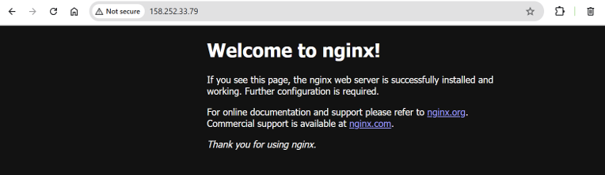
task4_my_playbook_droplet.png
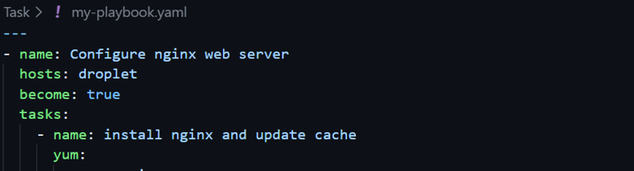
task4_ansible_play_droplet.png
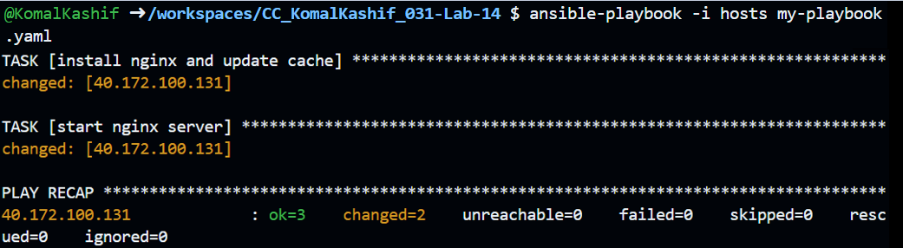

task4_nginx_browser_droplet.png
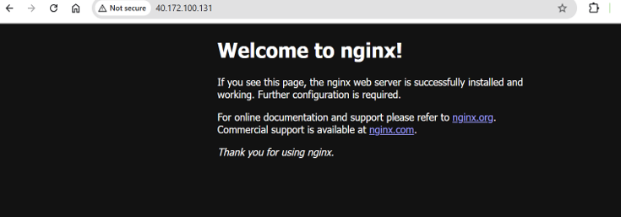
Task 5 – Single nginx target group & HTTPS prerequisites
task5_project_ansible_cfg_created.png
task5_project_ansible_cfg.png
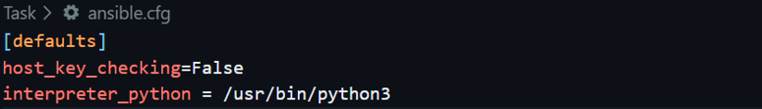
task5_main_tf_count_1.png
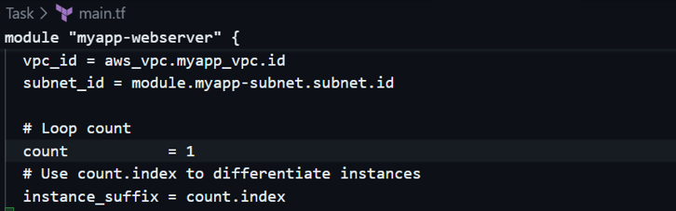
task5_terraform_apply_one_instance.png
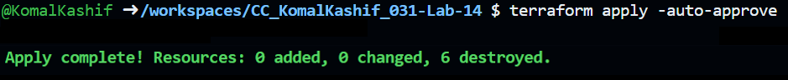
task5_terraform_output_single_ip.png
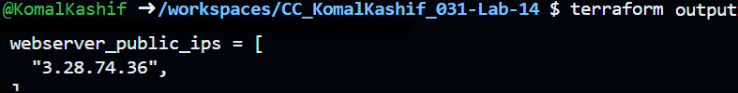

task5_hosts_nginx_group.png
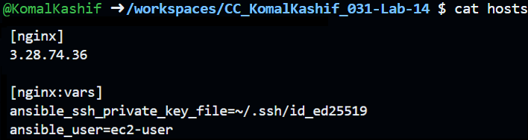
task5_my_playbook_nginx_group.png
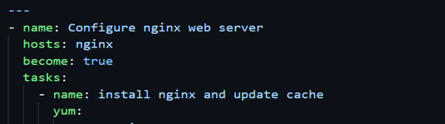
task5_ansible_play_nginx_group.png
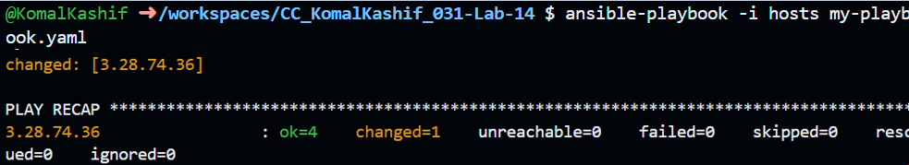
task5_nginx_browser_single.png
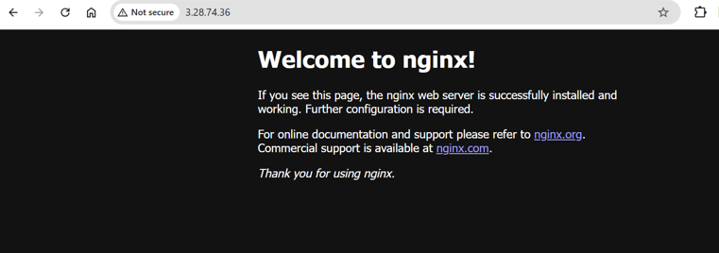
Task 6 - Ansible-managed SSL certificates
task6_my_playbook_ssl_section.png
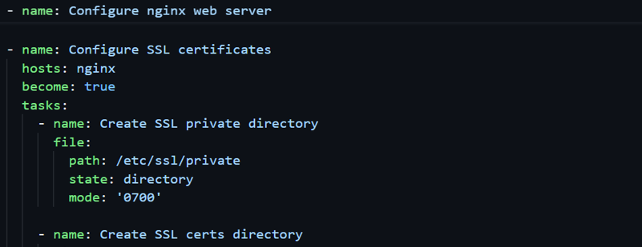
task6_ansible_play_ssl.png
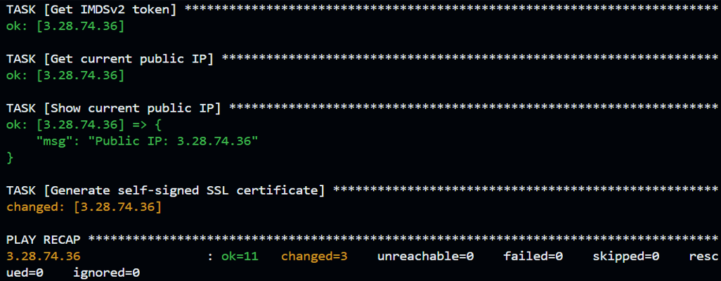
Task 7 - PHP front-end deployment with templates
task7_files_templates_created.png
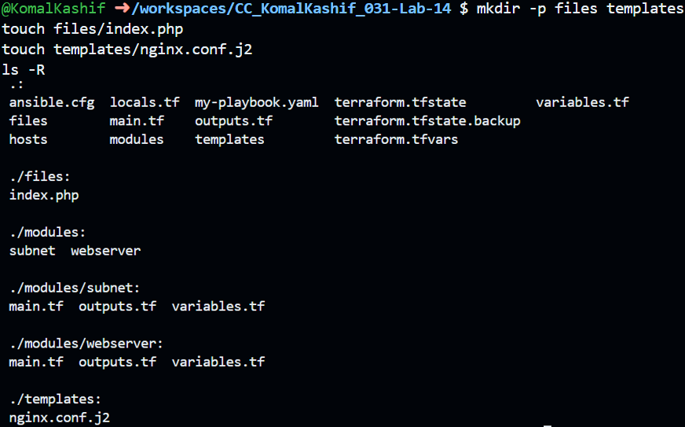
task7_index_php_content.png
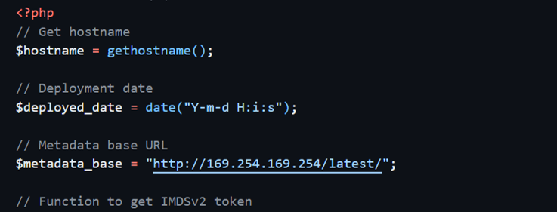

task7_nginx_conf_template.png
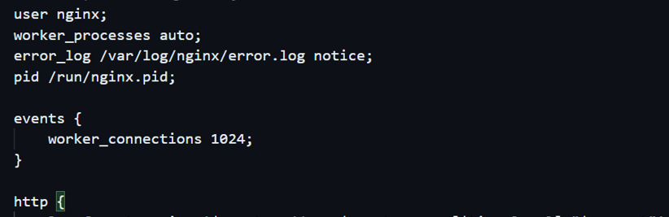
task7_my_playbook_web_deploy.png
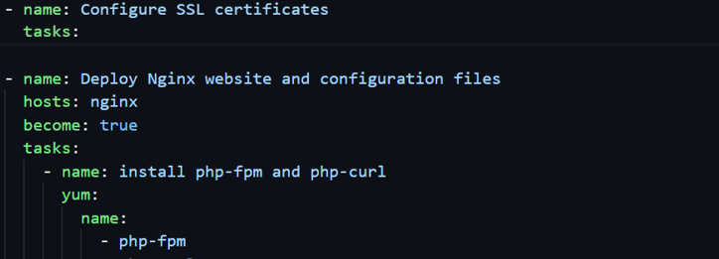
task7_ansible_play_web_deploy.png
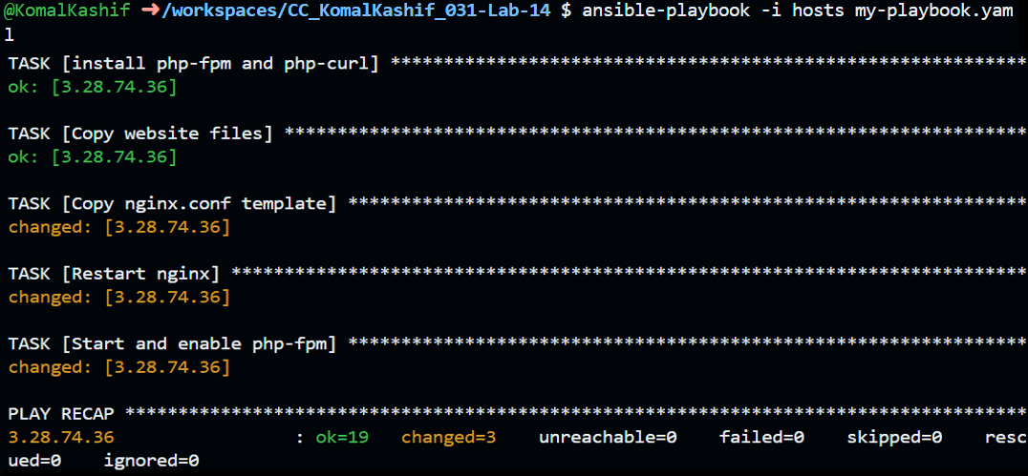
task7_php_https_browser.png
